ENGLISH

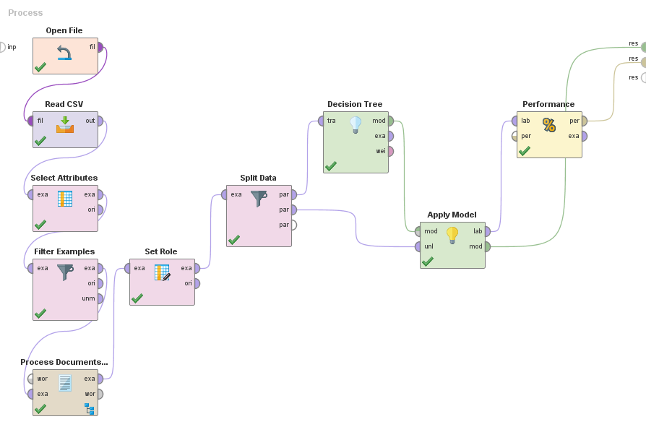

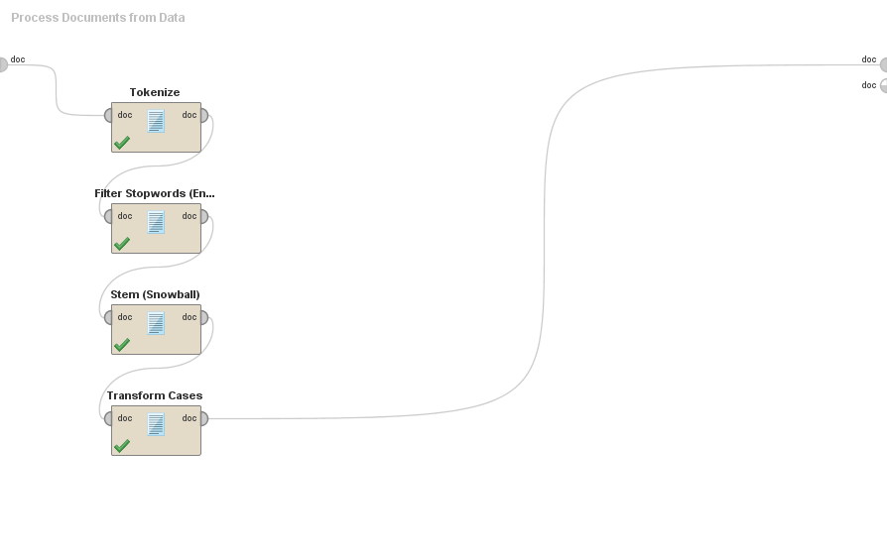

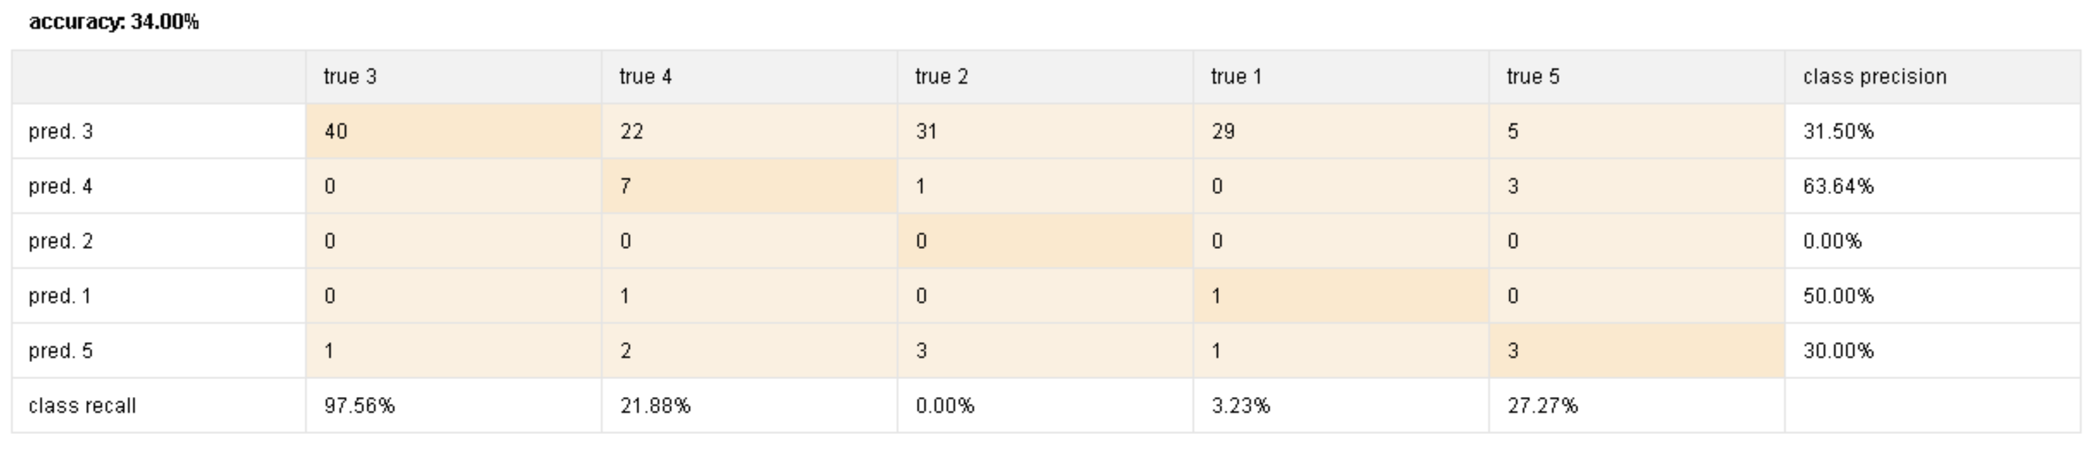

# Tree

aim > 0.179: 5 {3=0, 4=0, 2=0, 1=0, 5=2}

aim ≤ 0.179

| interview > 0.219: 5 {3=0, 4=0, 2=0, 1=0, 5=2}

| interview ≤ 0.219

| | mayb > 0.125: 5 {3=0, 4=0, 2=0, 1=0, 5=2}

| | mayb ≤ 0.125

| | | absolut > 0.158: 5 {3=0, 4=0, 2=0, 1=0, 5=1}

| | | absolut ≤ 0.158

| | | | angela > 0.124: 5 {3=0, 4=0, 2=0, 1=0, 5=1}

| | | | angela ≤ 0.124

| | | | | appeal > 0.145: 5 {3=0, 4=0, 2=0, 1=0, 5=1}

| | | | | appeal ≤ 0.145

| | | | | | banner > 0.107: 5 {3=0, 4=0, 2=0, 1=0, 5=1}

| | | | | | banner ≤ 0.107

| | | | | | | break > 0.251: 5 {3=0, 4=0, 2=0, 1=0, 5=1}

| | | | | | | break ≤ 0.251

| | | | | | | | campaign > 0.161: 5 {3=0, 4=0, 2=0, 1=0, 5=1}

| | | | | | | | campaign ≤ 0.161

| | | | | | | | | centr > 0.182: 5 {3=0, 4=0, 2=0, 1=0, 5=1}

| | | | | | | | | centr ≤ 0.182

| | | | | | | | | | coercion > 0.188: 5 {3=0, 4=0, 2=0, 1=0, 5=1}

| | | | | | | | | | coercion ≤ 0.188

| | | | | | | | | | | commit > 0.331: 5 {3=0, 4=0, 2=0, 1=0, 5=1}

| | | | | | | | | | | commit ≤ 0.331

| | | | | | | | | | | | matter > 0.334: 5 {3=0, 4=0, 2=0, 1=0, 5=1}

| | | | | | | | | | | | matter ≤ 0.334

| | | | | | | | | | | | | rule > 0.201: 1 {3=0, 4=0, 2=0, 1=5, 5=0}

| | | | | | | | | | | | | rule ≤ 0.201

| | | | | | | | | | | | | | violat > 0.092: 1 {3=0, 4=0, 2=0, 1=3, 5=0}

| | | | | | | | | | | | | | violat ≤ 0.092

| | | | | | | | | | | | | | | author_0 > 0.267: 4 {3=0, 4=4, 2=0, 1=0, 5=0}

| | | | | | | | | | | | | | | author_0 ≤ 0.267

| | | | | | | | | | | | | | | | support > 0.202: 4 {3=0, 4=4, 2=0, 1=0, 5=0}

| | | | | | | | | | | | | | | | support ≤ 0.202

| | | | | | | | | | | | | | | | | back > 0.229: 4 {3=0, 4=3, 2=0, 1=0, 5=0}

| | | | | | | | | | | | | | | | | back ≤ 0.229

| | | | | | | | | | | | | | | | | | immedi > 0.244: 4 {3=0, 4=3, 2=0, 1=0, 5=0}

| | | | | | | | | | | | | | | | | | immedi ≤ 0.244: 3 {3=62, 4=34, 2=52, 1=39, 5=0}

FRENCH



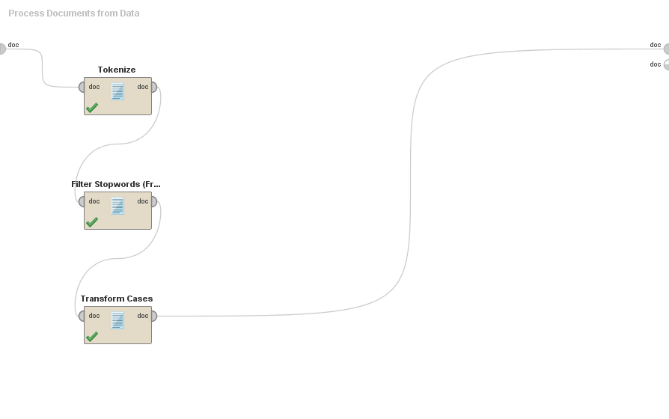

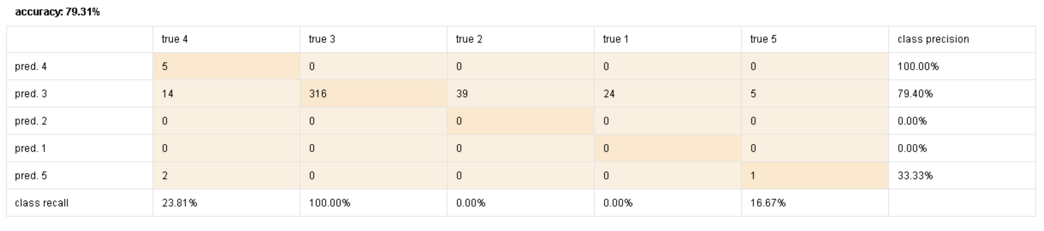

# Tree

justice > 0.336: 5 {4=0, 3=0, 2=0, 1=0, 5=2}

justice ≤ 0.336

| respect > 0.220: 5 {4=0, 3=0, 2=0, 1=0, 5=2}

| respect ≤ 0.220

| | accusés > 0.168: 5 {4=0, 3=0, 2=0, 1=0, 5=1}

| | accusés ≤ 0.168

| | | adéquatement > 0.137: 5 {4=0, 3=0, 2=0, 1=0, 5=1}

| | | adéquatement ≤ 0.137

| | | | cadeau > 0.188: 5 {4=0, 3=0, 2=0, 1=0, 5=1}

| | | | cadeau ≤ 0.188

| | | | | engrenage > 0.133: 5 {4=0, 3=0, 2=0, 1=0, 5=1}

| | | | | engrenage ≤ 0.133

| | | | | | fondement > 0.150: 5 {4=0, 3=0, 2=0, 1=0, 5=1}

| | | | | | fondement ≤ 0.150

| | | | | | | respecter > 0.070: 4 {4=5, 3=0, 2=0, 1=0, 5=0}

| | | | | | | respecter ≤ 0.070

| | | | | | | | solution > 0.096: 4 {4=5, 3=0, 2=0, 1=0, 5=0}

| | | | | | | | solution ≤ 0.096

| | | | | | | | | parties > 0.082: 4 {4=4, 3=0, 2=0, 1=0, 5=0}

| | | | | | | | | parties ≤ 0.082

| | | | | | | | | | attendait > 0.118: 4 {4=2, 3=0, 2=0, 1=0, 5=0}

| | | | | | | | | | attendait ≤ 0.118

| | | | | | | | | | | certain > 0.123: 4 {4=2, 3=0, 2=0, 1=0, 5=0}

| | | | | | | | | | | certain ≤ 0.123

| | | | | | | | | | | | gas > 0.207: 4 {4=2, 3=0, 2=0, 1=0, 5=0}

| | | | | | | | | | | | gas ≤ 0.207

| | | | | | | | | | | | | importance > 0.129: 4 {4=2, 3=0, 2=0, 1=0, 5=0}

| | | | | | | | | | | | | importance ≤ 0.129

| | | | | | | | | | | | | | accroît > 0.127: 4 {4=1, 3=0, 2=0, 1=0, 5=0}

| | | | | | | | | | | | | | accroît ≤ 0.127

| | | | | | | | | | | | | | | accuse > 0.327: 4 {4=1, 3=0, 2=0, 1=0, 5=0}

| | | | | | | | | | | | | | | accuse ≤ 0.327

| | | | | | | | | | | | | | | | arrestations > 0.141: 4 {4=1, 3=0, 2=0, 1=0, 5=0}

| | | | | | | | | | | | | | | | arrestations ≤ 0.141

| | | | | | | | | | | | | | | | | barrage > 0.140: 4 {4=1, 3=0, 2=0, 1=0, 5=0}

| | | | | | | | | | | | | | | | | barrage ≤ 0.140

| | | | | | | | | | | | | | | | | | champagne > 0.229: 4 {4=1, 3=0, 2=0, 1=0, 5=0}

| | | | | | | | | | | | | | | | | | champagne ≤ 0.229: 3 {4=4, 3=474, 2=59, 1=35, 5=0}

SPANISH



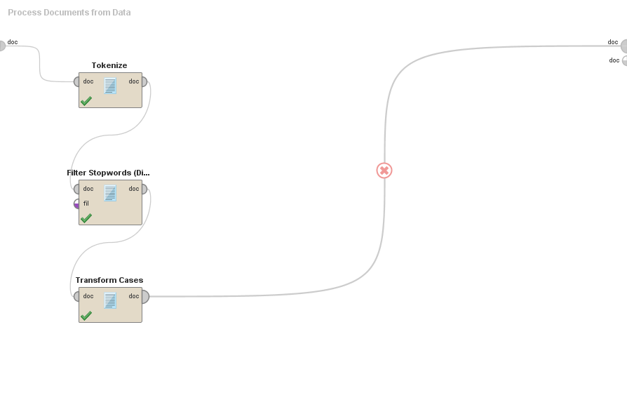

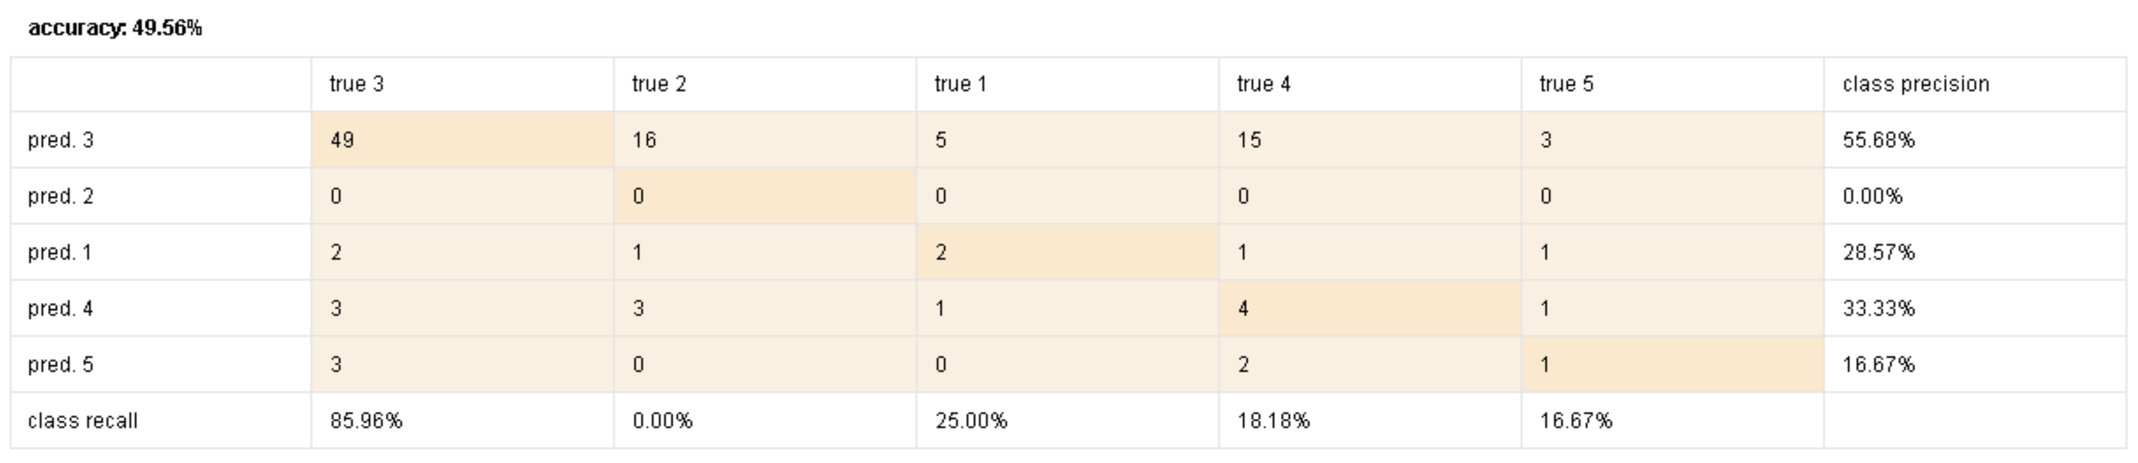

# Tree

confirma > 0.125: 1 {3=0, 2=0, 1=4, 4=0, 5=0}

confirma ≤ 0.125

| activado > 0.162: 5 {3=0, 2=0, 1=0, 4=0, 5=2}

| activado ≤ 0.162

| | dialogar > 0.109: 1 {3=0, 2=0, 1=2, 4=0, 5=0}

| | dialogar ≤ 0.109

| | | gravemente > 0.074: 1 {3=0, 2=0, 1=2, 4=0, 5=0}

| | | gravemente ≤ 0.074

| | | | actualizado > 0.147: 1 {3=0, 2=0, 1=1, 4=0, 5=0}

| | | | actualizado ≤ 0.147

| | | | | atender > 0.298: 1 {3=0, 2=0, 1=1, 4=0, 5=0}

| | | | | atender ≤ 0.298

| | | | | | contumaz > 0.202: 1 {3=0, 2=0, 1=1, 4=0, 5=0}

| | | | | | contumaz ≤ 0.202

| | | | | | | cosas > 0.172: 1 {3=0, 2=0, 1=1, 4=0, 5=0}

| | | | | | | cosas ≤ 0.172

| | | | | | | | desobediencia > 0.375: 1 {3=0, 2=0, 1=1, 4=0, 5=0}

| | | | | | | | desobediencia ≤ 0.375

| | | | | | | | | acordado > 0.283: 5 {3=0, 2=0, 1=0, 4=0, 5=1}

| | | | | | | | | acordado ≤ 0.283

| | | | | | | | | | ambigua > 0.128: 5 {3=0, 2=0, 1=0, 4=0, 5=1}

| | | | | | | | | | ambigua ≤ 0.128

| | | | | | | | | | | anunciar > 0.251: 5 {3=0, 2=0, 1=0, 4=0, 5=1}

| | | | | | | | | | | anunciar ≤ 0.251

| | | | | | | | | | | | apostado > 0.165: 5 {3=0, 2=0, 1=0, 4=0, 5=1}

| | | | | | | | | | | | apostado ≤ 0.165

| | | | | | | | | | | | | catalana > 0.203: 5 {3=0, 2=0, 1=0, 4=0, 5=1}

| | | | | | | | | | | | | catalana ≤ 0.203

| | | | | | | | | | | | | | comparecido > 0.218: 5 {3=0, 2=0, 1=0, 4=0, 5=1}

| | | | | | | | | | | | | | comparecido ≤ 0.218

| | | | | | | | | | | | | | | dado > 0.235: 5 {3=0, 2=0, 1=0, 4=0, 5=1}

| | | | | | | | | | | | | | | dado ≤ 0.235

| | | | | | | | | | | | | | | | espa > 0.123: 4 {3=0, 2=0, 1=0, 4=5, 5=0}

| | | | | | | | | | | | | | | | espa ≤ 0.123

| | | | | | | | | | | | | | | | | tras > 0.179: 4 {3=0, 2=0, 1=0, 4=5, 5=0}

| | | | | | | | | | | | | | | | | tras ≤ 0.179

| | | | | | | | | | | | | | | | | | puigdemont > 0.141: 4 {3=0, 2=0, 1=0, 4=4, 5=0}

| | | | | | | | | | | | | | | | | | puigdemont ≤ 0.141: 3 {3=86, 2=31, 1=0, 4=20, 5=0}

CATALAN

# 

# 

# 

# Tree

perqu > 0.166: 1 {3=0, 4=0, 5=0, 1=3, 2=0}

perqu ≤ 0.166

| mediadors > 0.100: 1 {3=0, 4=0, 5=0, 1=2, 2=0}

| mediadors ≤ 0.100

| | actuat > 0.128: 1 {3=0, 4=0, 5=0, 1=1, 2=0}

| | actuat ≤ 0.128

| | | agrair > 0.154: 1 {3=0, 4=0, 5=0, 1=1, 2=0}

| | | agrair ≤ 0.154

| | | | allä > 0.108: 1 {3=0, 4=0, 5=0, 1=1, 2=0}

| | | | allä ≤ 0.108

| | | | | abast > 0.092: 5 {3=0, 4=0, 5=1, 1=0, 2=0}

| | | | | abast ≤ 0.092

| | | | | | acabar > 0.155: 5 {3=0, 4=0, 5=1, 1=0, 2=0}

| | | | | | acabar ≤ 0.155

| | | | | | | als > 0.143: 5 {3=0, 4=0, 5=1, 1=0, 2=0}

| | | | | | | als ≤ 0.143

| | | | | | | | anys > 0.225: 5 {3=0, 4=0, 5=1, 1=0, 2=0}

| | | | | | | | anys ≤ 0.225

| | | | | | | | | civils > 0.157: 5 {3=0, 4=0, 5=1, 1=0, 2=0}

| | | | | | | | | civils ≤ 0.157

| | | | | | | | | | pot > 0.067: 4 {3=0, 4=3, 5=0, 1=0, 2=0}

| | | | | | | | | | pot ≤ 0.067

| | | | | | | | | | | aixä > 0.063: 4 {3=0, 4=2, 5=0, 1=0, 2=0}

| | | | | | | | | | | aixä ≤ 0.063

| | | | | | | | | | | | autonomisme > 0.092: 4 {3=0, 4=2, 5=0, 1=0, 2=0}

| | | | | | | | | | | | autonomisme ≤ 0.092

| | | | | | | | | | | | | espanyola > 0.096: 4 {3=0, 4=2, 5=0, 1=0, 2=0}

| | | | | | | | | | | | | espanyola ≤ 0.096

| | | | | | | | | | | | | | aprovat > 0.244: 4 {3=0, 4=1, 5=0, 1=0, 2=0}

| | | | | | | | | | | | | | aprovat ≤ 0.244

| | | | | | | | | | | | | | | banda > 0.284: 4 {3=0, 4=1, 5=0, 1=0, 2=0}

| | | | | | | | | | | | | | | banda ≤ 0.284

| | | | | | | | | | | | | | | | dit > 0.110: 2 {3=0, 4=0, 5=0, 1=0, 2=3}

| | | | | | | | | | | | | | | | dit ≤ 0.110

| | | | | | | | | | | | | | | | | catalunya > 0.157: 2 {3=0, 4=0, 5=0, 1=0, 2=2}

| | | | | | | | | | | | | | | | | catalunya ≤ 0.157

| | | | | | | | | | | | | | | | | | espanyol > 0.112: 2 {3=0, 4=0, 5=0, 1=0, 2=2}

| | | | | | | | | | | | | | | | | | espanyol ≤ 0.112: 3 {3=16, 4=0, 5=0, 1=0, 2=3}

ALL

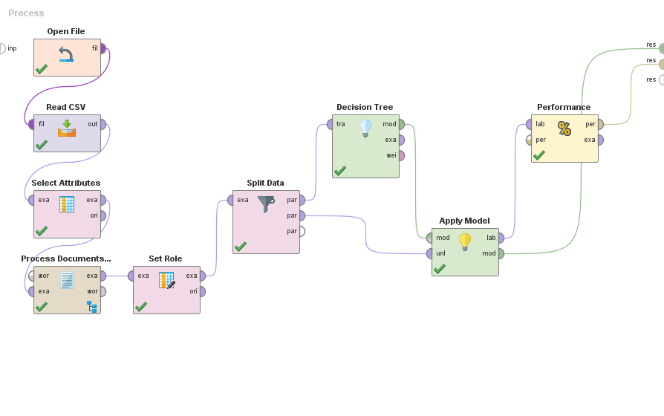

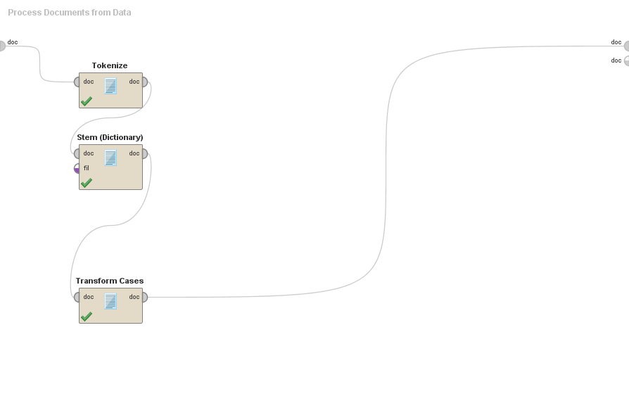

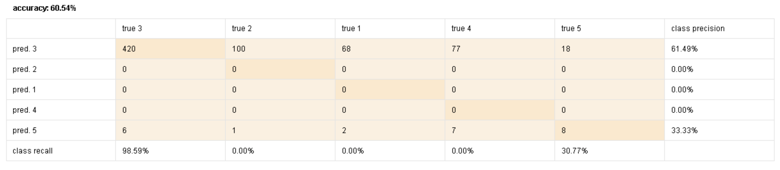

**Tree**

absolute > 0.043: 5 {3=0, 2=0, 1=0, 4=0, 5=3}

absolute ≤ 0.043

| justice > 0.193: 5 {3=0, 2=0, 1=0, 4=0, 5=3}

| justice ≤ 0.193

| | acordado > 0.089: 5 {3=0, 2=0, 1=0, 4=0, 5=2}

| | acordado ≤ 0.089

| | | aimed > 0.134: 5 {3=0, 2=0, 1=0, 4=0, 5=2}

| | | aimed ≤ 0.134

| | | | catalana > 0.139: 5 {3=0, 2=0, 1=0, 4=0, 5=2}

| | | | catalana ≤ 0.139

| | | | | decidir > 0.064: 5 {3=0, 2=0, 1=0, 4=0, 5=2}

| | | | | decidir ≤ 0.064

| | | | | | activado > 0.148: 5 {3=0, 2=0, 1=0, 4=0, 5=1}

| | | | | | activado ≤ 0.148

| | | | | | | actualizado > 0.148: 5 {3=0, 2=0, 1=0, 4=0, 5=1}

| | | | | | | actualizado ≤ 0.148

| | | | | | | | adéquatement > 0.122: 5 {3=0, 2=0, 1=0, 4=0, 5=1}

| | | | | | | | adéquatement ≤ 0.122

| | | | | | | | | agradecer > 0.134: 5 {3=0, 2=0, 1=0, 4=0, 5=1}

| | | | | | | | | agradecer ≤ 0.134

| | | | | | | | | | agree > 0.182: 5 {3=0, 2=0, 1=0, 4=0, 5=1}

| | | | | | | | | | agree ≤ 0.182

| | | | | | | | | | | albeit > 0.114: 5 {3=0, 2=0, 1=0, 4=0, 5=1}

| | | | | | | | | | | albeit ≤ 0.114

| | | | | | | | | | | | algunas > 0.130: 5 {3=0, 2=0, 1=0, 4=0, 5=1}

| | | | | | | | | | | | algunas ≤ 0.130

| | | | | | | | | | | | | arch > 0.159: 5 {3=0, 2=0, 1=0, 4=0, 5=1}

| | | | | | | | | | | | | arch ≤ 0.159

| | | | | | | | | | | | | | banner > 0.094: 5 {3=0, 2=0, 1=0, 4=0, 5=1}

| | | | | | | | | | | | | | banner ≤ 0.094

| | | | | | | | | | | | | | | break > 0.220: 5 {3=0, 2=0, 1=0, 4=0, 5=1}

| | | | | | | | | | | | | | | break ≤ 0.220

| | | | | | | | | | | | | | | | calmness > 0.074: 5 {3=0, 2=0, 1=0, 4=0, 5=1}

| | | | | | | | | | | | | | | | calmness ≤ 0.074

| | | | | | | | | | | | | | | | | campaign > 0.129: 5 {3=0, 2=0, 1=0, 4=0, 5=1}

| | | | | | | | | | | | | | | | | campaign ≤ 0.129

| | | | | | | | | | | | | | | | | | cap > 0.379: 5 {3=0, 2=0, 1=0, 4=0, 5=1}

| | | | | | | | | | | | | | | | | | cap ≤ 0.379: 3 {3=638, 2=151, 1=105, 4=125, 5=12}